

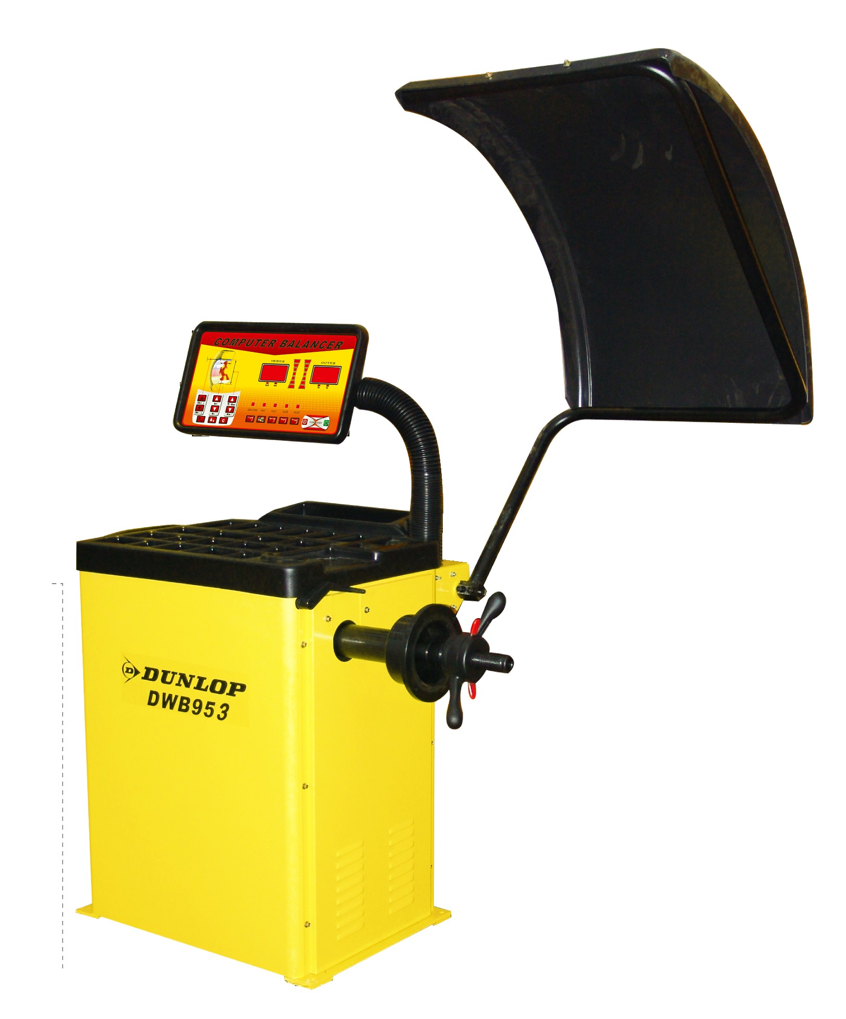

DWB953 – Máquina Equilibradora

Manual de Instrucciones

Las especificaciones de este manual no están condicionadas, y debido al continuo proceso de desarrollo y perfeccionamiento se reserva el derecho de cambiar cualquier especificación sin previa notificación.

153-165 Bridge Street,
Northampton
NN1 1QG
United Kingdom

www.dunlopge.co.uk

(Blank Page)

6.2 PANEL DE CONTROL
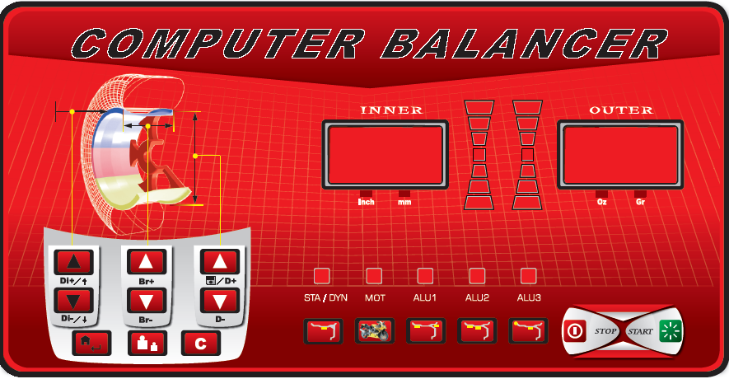



- Tecla de ajuste de distancia. Presione para ajustar el valor de distancia analizada en el indicador.


- Tecla de ajuste de anchura. Presione para ajustar el valor de la anchura medida en el indicador.


- Tecla de ajuste de diámetro. Presione para ajustar el valor del diámetro medido en el indicador.

(4) Tecla de equilibrado de alta precisión. El indicador muestra “00” cuando el desequilibrio es menor de 5g. Presione está tecla para conocer el desequilibrio existente.


(5) Tecla de conversion del valor de desequilibrio


(6) Tecla de selección de modalidad Statica/ Motocicleta/ Dinamica/ ALU


(7) Tecla de apagado de emergencia


(8) Tecla de encendido


9) Valor del desequilibrio interior y pantalla de parametros de neumatico


(10) Valor del desequilibrio exterior y pantalla de parametros de neumatico

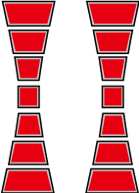

(11) Lámpara de posición del valor de desequilibrio



(12) Lámpara de modalidad de equilibrio individual

6.3 Uso basico

6.3.1
Presone la tecla de encendido del lateral izquierdo de la máquina equilibradora，La pantalla 9 mostrará
“CB-953” y despues “0”、“0”（mostrará “0.00”, “0.00” in ounce state）
Puede seleccionar modalidades diferentes según la práctica.

6.3.2.1 RUEDAS DE COCHES PEQUENOS – POSICIÓN POSITIVA
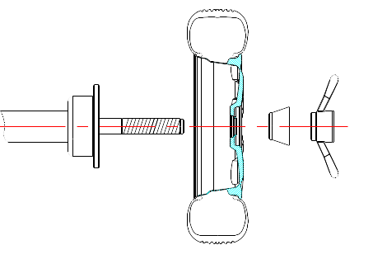
FIG7

La posición positive es el método normal. Es caracterizado de una operación simple y rápida. Es principalmente apropiado para llantas ordinarias de acero y llantas de aleación con una mínima deformación.

Eje rotacional rueda（la instalación de dirección de la llanta es interna) cono
Tuerca manual

6.3.2.2
Cuando la deformación de la rueda es en el exterior, utilize esta modalidad para posicionar correctamente el agujero interior de la llantas de acero y el eje rotacional. Es apropiado para llantas de acero, especialmente las llantas de aleación espesas
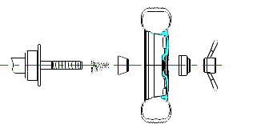
FIG 8

rim.

Eje rotacional tower spring suitable cone wheel bowl quick nut

6.3.2.3 FLANGE DISK POSITIONING（OPTIONAL）
Suitable for larger wheels
Main shaft flange disk（fixed on the main shaft） wheel cone quick nut

The choice on the cone should be adapted to the rim center hole and pay attention to its direction. Or it will cause the inaccurate measurement.

6.4 INPUT VALUE
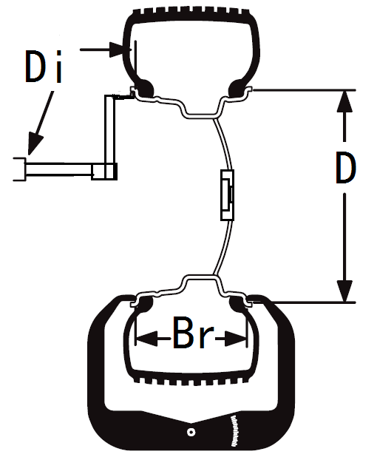
Fig10

6.4.1 Input (Di)stance
Press the key to input the Di value into the display. At this moment, the display will display “Di”：“XXX”，And we can also adjust this value by rotating the tyre fixed on the main shaft.
6.4.2 Input (Br)eadth Value
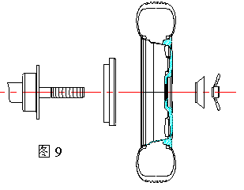
Use the Br measurement caliper to measure the Br of the rim, press the key to input the Br value into the display. At this moment, the display will display “Br”：“XXX”，And we can also adjust this value by rotating the tyre fixed on the main shaft.
FIG9

6.4.3 Input the Tyre Diameter Value
After confirming the rim diameter, press the key to input the rim diameter into the display. At this moment, the display will display “D”：“XXX”，And we can also adjust this value by rotating the tyre fixed on the main shaft.

6.4.4 UNIT CONVERSION：


①The unit conversion of the Br of the rim from inch to mm:
Normally, the display of Br should be in inch. When you need the unit of the display to be
mm, you can use the key to realize the unit conversion from inch to mm.
②The unit conversion of the D of the rim from inch to mm:
Normally, the display of D should be in inch. When you need the unit of the display to be mm, you can use the key to realize the unit conversion from inch to mm.

After unit conversion, the unit of the display values of rim Br and D are , but when you switch off and then on the wheel balancer, the unit will be still inch.

③The unit conversion from gram to ounce：
Normally, the unit of the unbalance value is gram (g). If you want to make the ounce(Oz) to be the unit,you can execute the g/Oz conversion.
The unit of the displayed unbalance value is gram（g）. The way to realize the unit conversion from gram to ounce is to press 。
6.4.5 When press the start key ，the
wheel balancer starts to run. A few seconds later,
the machine automatically stops. The machine can also start by lowering down the protective cover which can be set by the program.

6.4.6 DISPLAY UNBALANCE VALUE

When the spin ends, the display will display the

inner and outer unbalance value of the rim. Use your hand to pull the wheel. When all the positioning lamps light inside and outside light, the weight adding position will be indicated.

6.4.7 Rotate the wheel, when the left side positioning lamp all light, at this moment, the highest position is the inner unbalance position and when the right side positioning lamp all light, at this moment, the highest position is the outer unbalance position.

6.4.8 Add the corresponding weight at the unbalance point and start test again until the balance of the tyre.

- When start the machine, use hand to pull the wheel to help it start rotation, especially to the relative bigger tyre, to prolong the working life of the motor.
- Check if there are any mistakes on the dimension.
- Check if the balance methods meet the configuration of the rim and select the balancer most easily to balance.
- Check if the contract nut tight or not.
- When the balance ends, remove the tyre. Pay attention to handle it with gentle and avoid knocking the main shaft.
- When clipping the weight. Use the hammer to clip the weight on the rim without too much force.

Do not knock the main shaft hardly to avoid
damaging the sensor. The position to add the
weight should
be free from the grease and should be dry.

6.5 UNBALANCE VALUE DISPLAY RESIDUAL
The minimum value of the standard weight is 5g so if the weight you use is less than 5 g, the wheel balancer will not display the value and only displays the state of “00”. When you need to display the residual unbalance value, you should press and the display will immediately display the inside or outside unbalance value of less than 5g. The maximum residual unbalance value is 4 g.

7 PROGRAM SETUP
7.1 PROGRAM FUNCTION INTRODUCTION
Press program key  to enter the program setup menu.
-p- (protective cover set-up) Press key
again to confirm the entrance. Select set up the ON& OFF of the protective cover control function. Press key to confirm to return to the above level.

SP（protective cover control function set-up）Select to enter. Press to confirm the entrance. The set up see the above.

APP(minimum unbalance value setup) can setup to 1Grand 5Gr。
BIP (beeper setup) setup the on and off of the beeper
UP ENT Press to enter the special function setup.
IN TES (sensor test) can test the photocell and stat/dynamic piezoelectric sensor.
SELECT ON THE NEXT MENU
Enter into CAL –CAL，this function is used when long time no use of the machine or the lost of the
accuracy. Press to enter the program
and press to confirm and the display will display ADD -0. Press the start key to start the test. After running ,the display will display ADD -100. Rotate the tyre and clip a weight of 100g at the 12clock position when all the unbalance position indication lamps light. And then start the machine again to realize the self calibration.

The above operation step vector diagram is as follows：

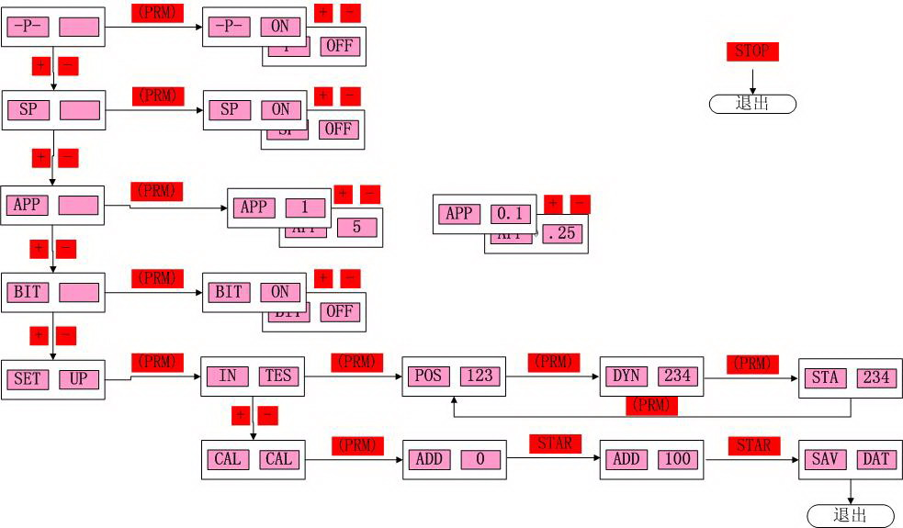

2 ERROR INDICATION

DISPLAY | CAUSE | SOLUTION
ERR OPN | protective cover not lower down | Lower down the protective cover
ERR SP | rotation speed not enough | Check the motor and belt.
ERR OFF | stop the error | Press the start key or raise up the protective cover.
ERR FAC | factory set-up fault | Correct factory set-up
ERR USR | customer set-up fault | set-up fault

If the problems still cannot be solved, please contact with the professional persons.

When changing the computer board, phase sensor or pressure sensor, you should self-calibrate again.

7.3 GENERAL TROUBLESHOOTING & SOLUTION
Description | Cause | Solution
Start the machine but not display. | - .Check the circuit of 220V is normal or not.  - power board fault  - The cable between the power board and computer loose  - computer board fault | - Check and connect the external power source.  - Changer the power board  - Check the plug cable  - Change the computer board
Display is normal but the start button and input push button not working. | - contact switch not good  - machine breakdown | 1. Open the housing of the machine and plug in and tight the contact switch plug.  2. Start the machine again
Display is normal but not braking after start. | - The cable between the power board and computer loose  - power board fault  - computer board fault | - Plug in and tight the cable between the computer board and power board.  - Change the power board  - Change the computer board

Balance is not accurate & difficult to reach “00” | - sensor lead connect or contact no good  - memory value lost | 1.Connect again  2. Correct the memory value according to the manual.
Each spin, the change of the value will not exceed 5g. | - There are foreign body on the rim or the assemble surface in the rim center deformation  - sensor damp or quick nut not tightly clamped  - The external power voltage or the air pressure not enough. The flange dick not locked. | - Change the wheel  - Oven, recalibrate the sensor.  - Fix the anchor bolt.
Each spin, the range of the change of value will be 20-90g. | - There are foreign bodies on the wheel or the unbalance of the wheel value too big.  - sensor damage  - external power source voltage too low | - Change the wheel  - Check the sensor and wiring.  - Check power source and assemble stabilizer.
Balance is not accurate & difficult to reach “00” | - Sensor damp or damage  - Program chore | - Calibrate again,oven and then self-calibration or change.  - Self-calibration again
When second mount & demount, the error will exceed 10g. | - Wheel internal hole irregular  - Flange disk assemble not properly | - Change the wheel  - Check the assemble surface and try again.

Fig11

. DETAILED MACHINE OPERATION：

  - How to balance a tire?
1. Switch on the power source
2. Select the cone according to the tire. Assemble the tire on the main shaft of the wheel balancer and firmly lock it.
3. Input the tire parameter.
3.1 Pull out the scale of the balancer to measure the Di value which means the distance from the insider of the tire to the body.

According to measured reading, the unit of which

is cm, press to adjust the value to make the value displayed in the right side window to be the measured value. But the unit of this displayed value is mm. eg You should input 55mm if the measured value is 5.5cm.

3.2 Use the width measurement scale to measure the Br value means the rim distance.Press
to input the Br value which is the implied value with the unit of inch. If you want to convert this value into the value with the unit of mm,
you can press torealize the conversion between the units.
3.3 Check the D value, which means the diameter
of the rim, marked on the tire. Press to
adjust the displayed in the right side display
window until the displayed value to be the rim
diameter value. You can also use to
realize the conversion of the Br unit.

4、Lower down the protective cover（you can also
press the start key）. After the machine start,
rotate and
test, it will automatic stops. In the left /right
window ,the corresponding values will be
displayed. Rotate
the tire, when all the position indication lamps
light. Pls add the weight corresponding to the
value
displayed in the window. Once again, start the
machine to test. The window will display thye
unbalance
value. The balance process will be completed
until reaching the balance range you requied.

  - MACHINE PARAMETER SETUP
Press program key to enter the program set-up menu.
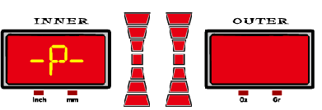
  - -p- (protective cover set) press key
to confirm the enter.
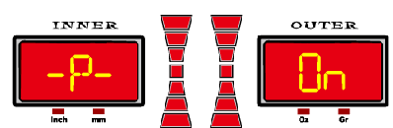
Select key to setup the on and off of the
protective cover . Press
1.2 –SP-( protective cover function set)，
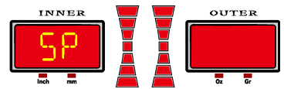

Press key to confirm the enter.
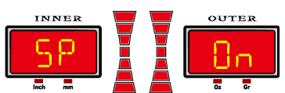
Select key to setup the on and off of the protective cover control function . Press
Press to confirm.
1.3 APP(minimum unbalance value setup) Press按can enter to setup the unit of 1Gr and 5Gr. All adopts diagraph not arrow. Press confirm enter, pres 、to adjust the selection of the corresponding unit. Press to adjust.
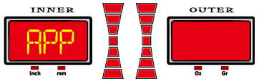

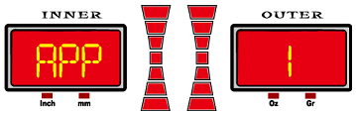
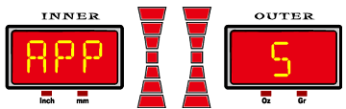
1.4 BIP (beeper setup) press can setup on/off of the beeper.
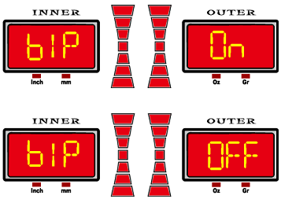

1.5 Press the to enter into the next level
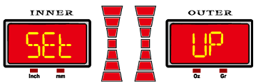
“UP”— “Ent” press key to enter the special functiosetup. There are 2 optional selection “IN”– “TES” and “CAL” –“CAL”
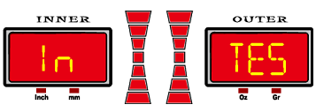
Press to enter.
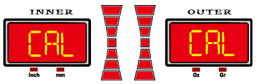

In the state of ＩＮ”—“ＴＥＳ”, pressto enter into the test test.
In the state of POS, rotate the tire clockwise. The value in the right window will increase. If counterclockwise, it will decrease.
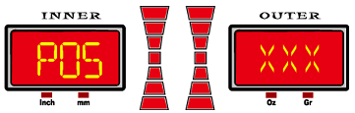

In the state of STA, press piezoelectric sensor vertical to the main shaft. And the value in the right window will increase. When loose your hand, the value will decrease. This means the installation of the sensor is correct.
In the state of STA, press pie
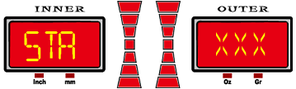

zoelectric sensor parallel to the main shaft. And the value in the right window will increase. When loose your hand, the value will decrease. This means the installation of the sensor is correct.
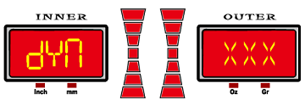

9.3 Autocalibración del usuario

Cuando la máquina está en posición de IN TES, presionar en para acceder al modo de auto-calibración CAL –CAL. Esta function solamente se debe utilizar bien cuanod la máquina no se haya utilizado durante mucho tiempo o bien cuando se haya perdido la precision de la misma.
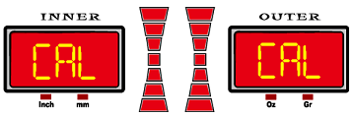

Presionar .para entrar en el programa. Presionar otra vez para confirmar.
El acceso a esta function se puede llevar a cabo una vez se hayan introducido los parametros de la rueda a calibrar. Entonces presionar y mantener la tecla del display

Tras 5 segundos, se entra en:
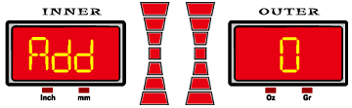 Presionar para acceder, a continuación el display mostrará “ADD”-“O”

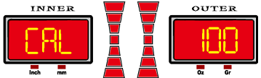
Presionar para lanzar la rueda primeramente.
A continuación mostrará “ADD”-“100”, entonces hacer girar la rueda a mano. Cuando todas las luces de posicionamiento de la derecha estén encendidas, poner el peso de 100g en posición de las 12 en punto en el lado de fuera. De no estar en esta posición, el ángulo de la máquina para los calculus sera erróneo y por tanto impreciso, de igual modo puede tener un efecto sobre la precision de las mediciones de la equilibradora. Si se reinicia la máquina en este momento habrá que reiniciar el proceso desde el inicio.
Presionar para iniciar la máquina.

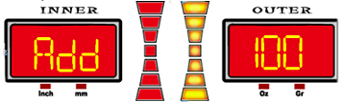

Tras llevar a cabo la autocalibración de usuario, en el display aparecerá “SAU”-“DAT”, confirmar y terminar la autocalibración.
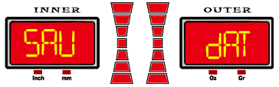

9.4 Calibración precisa de la máquina
Normalmente no se utilize esta función. Cuando no se puede lograr que la equilibradora alcance la precision deseable, tras el paso 9.3, solamente entonces se recurre a este tipo de calibración. Antes de usar esta function, siga estrictamente los siguientes pasos para calibrar la equilibradora. La calibración inapropiada puede provocar errore permanentes en el equipo
En el modo de “test” “IN”_“TES”, presione la tecla de acceso para pasar a “POS”
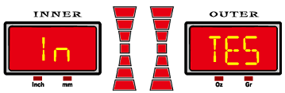

Al girar la rueda, la POS cambiará al mismo tiempo, cuando muestre que POS es“110”, presionar la tecla .
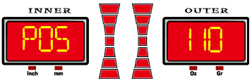

A continuación continuar haciendo girar la rueda hace delante o hacia atrás. Cuando el display de POS cambie a “120”, presionar la tecla nuevamente.
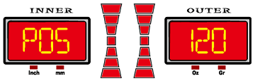
Ahora nos meteremos el la calibración precisa de fabricación.

Presionar "start . La máquina se parará automaticamente después de la rotación, mientras que la máquina mostrará.
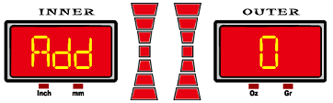
En este punto, cuando todas las luces indicadores estén encendidas, añadir el peso de 100g en la posición de las 12 en punto de la llanta y baje la capota para que comience a girar.
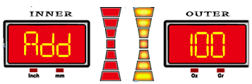
La rotación para y el display muestra “100”-“add”
Ahora, cuando todos los indicadores del lado izquierdo estén encendidos, añadir el peso de 100g en la posición de las 12 en punto de la llanta y presionar
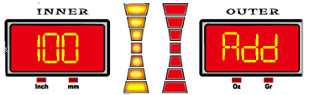
Cuando acabe la rotación el display aparecerá.
Si comienza la señal acustica, se oirá un pitido. Lo que nos indica que la auto-calibración con los valores de fábrica se han reestablecido y la máquina recupera la precisión.
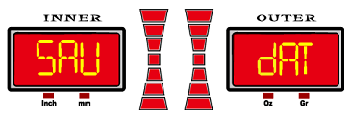

APPENDIX 1
LAYOUT OF THE POWER SUPPLY CARD-

APPENDIX 2
Wiring Diagram
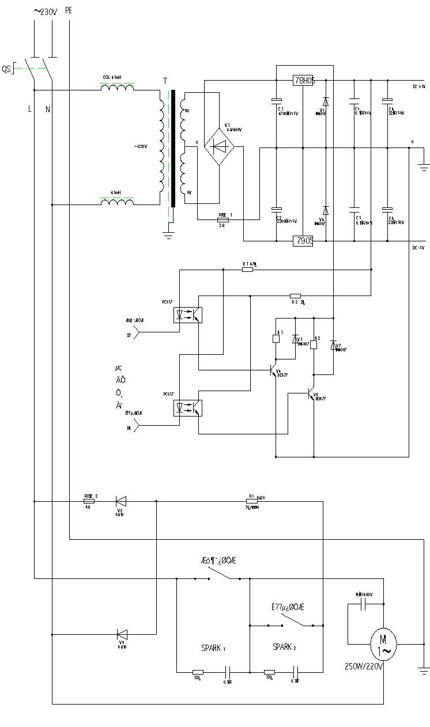

(Rev.01– 2008.09.01)

